Example name:

Template completed by:  Name, affiliation and email | Photographs
For installations

BISTS Location: place, longitude, latitude
Climate Type: Köppen climate classification
Building Use: residential, commercial, etc

Level of BISTS integration
Rush or Reijenga classification

O New Build
O Refurbishment
O Other: ……………………
tick all that apply
Type of BISTS:  Active/Passive/Hybrid  delete as appropriate  Function(s):  O Air heating  O Water heating  O Combi-system  O Cooling/ventilation/shading  O PV/T  O linked to another system  (e.g., heat pump)  O Other: ……………………….  tick all that apply | Drawings/Sketches/Cross-sections
Building element:

O Facade
O Roof
O Other: ……………………..
tick all that apply
BISTS characteristics:

For example…..Collection area….m², Orientation/inclination, Energy output, Contribution to building load, Material/colour/texture, Pre-fabricated off-site? Structural load, Other

Stage of Development: Responsible: Research institute, Company, etc.

O Idea/Patent …………………………………..
O Prototype …………………………………..
O Demonstration …………………………………..
O Integral building element …………………………………..
O Commercially available …………………………………..
tick all that apply
BISTS description and context

For example….Building size, form and function, project motivation, particular features, architectural attributes

System viability

For example….Economic viability (capital and running costs), maintenance, embodied energy, environmental impact and sustainability, wider social contexts

Modelling and simulation tools developed/used

For example….new modules/types created for established simulation programs, stand-alone modelling, use of generalised codes, model outcomes, validation and accuracy. Design tools developed

BISTS Performance data  Based on:  O Estimation  O Detailed simulation  Specify software(s) used  O Measurement/testing  O Long-term monitoring  tick all that apply  Performance parameters  For integrated systems:  key performance indicators -  Solar savings fraction: %  Light transmittance: %  Solar transmittance: %  Total solar energy transmittance: %:  Solar heat gain factor: %  Building fabric U-values: W/m²K  Noise, fire, etc ratings  Other:  For separate collectors:  performance rating coefficients -  (EN12975, a0,a1,a2), ASHRAE, etc  Other: |  | Graphs for collector efficiency, seasonal energy gains, diurnal/seasonal solar fraction, etc.
Additional information:
Sources and references:

INSTRUCTIONS

Please fill in as much information as possible.

Tick where appropriate.

Text in red is suggested guidance. Insert information in provided space, removing red text as appropriate

If possible, use metric values.

If necessary, supply additional information on separate sheets

Reference listing

Köppen climate classification
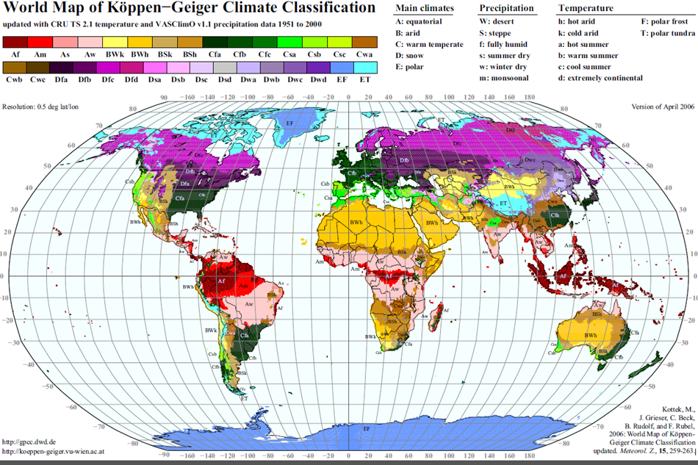

(Kottek, M., J. Grieser, C. Beck, B. Rudolf, and F. Rubel, 2006: World Map of Köppen-Geiger Climate Classification updated. Meteorol. Z., 15, 259-263.)

Reijenga classification
The integration of PV systems in architecture can be divided into five categories:

1. Applied invisibly
2. Added to the design
3. Adding to the architectural image
4. Determining architectural image
5. Leading to new architectural concepts.

(Reijenga, TH and Kaan, HF. (2011) PV in Architecture, in Handbook of Photovoltaic Science and Engineering, Second Edition (eds A. Luque and S. Hegedus), John Wiley & Sons Ltd, Chichester, UK)

Rush classification
The architectural/visual expression of building services systems are identified as:

Level 1. Not visible, no change
Level 2. Visible, no change
Level 3. Visible, surface change
Level 4. Visible, with size or shape change
Level 5. Visible, with location or orientation change

(Rush, RD. (1986) The Building systems integration handbook Wiley, New York, USA)

Collector test standards

BS EN 12975-2 2006 ‘Thermal solar systems and components solar collectors - Part 2 test methods’
ASHRAE Standard 93-2010 ‘Methods of Testing to Determine the Thermal Performance of Solar Collectors’
ASHRAE Standard 95-1987 ‘Methods of Testing to Determine the Thermal Performance of Solar Domestic Water Heating Systems’

